**“Java Syntax Matching” User Guide**

This document guides you in how to use the game application “Java Syntax Matching”.

1. Open the file “java_syntax_matching.exe” by going to the folder where that file is saved in after you downloaded it. Below shows how the file icon looks like (see the file circled in red).

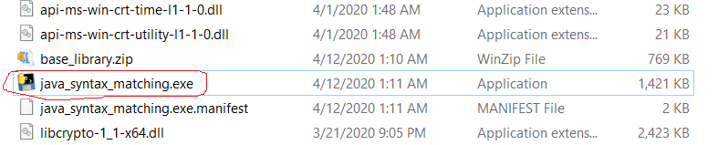

1. Below shows what is initially shown when you have double clicked the application. The text in black is the path to the executable file (which might be different in your PC).

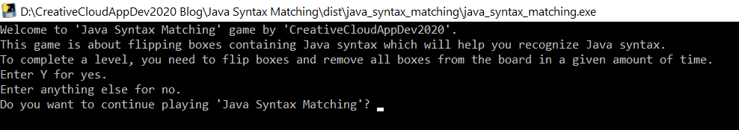

1. If you enter anything besides ‘Y’ when your asked something like in the screenshot above, you’ll quit the application.
2. Entering ‘Y’ will get you to level 1 of the game.

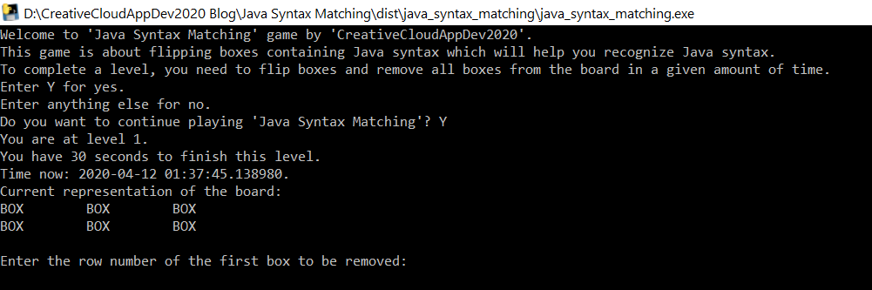

1. As the level progresses, you will be asked to enter the row and column numbers of the two boxes to be removed until either you run out of time or complete the level. If you complete the level, you will be notified that you won. Next, if you enter ‘Y’ after being asked the question as in the screenshot above step 3, you will advance to the next level and the next level is harder. If you enter anything besides ‘Y’ at the time being asked the question as in the screenshot above step 3, you will quit the game. If you failed to complete the level, you will stay at that level and be asked the question as in the screenshot above step 3.

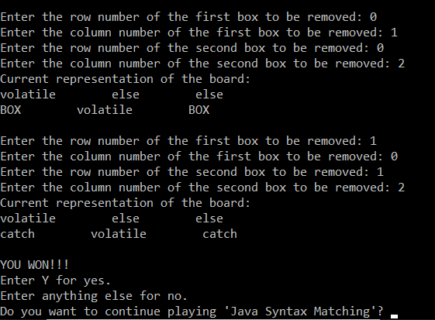

1. As the screenshot above demonstrates level 1, below shows how level 2 looks like.

